7.2.1 Best Practices 2022-23
Best Practice 1: Health Awareness
Spiritual Health Awareness
https://dhcollege.ac.in/event-details.php?id=304
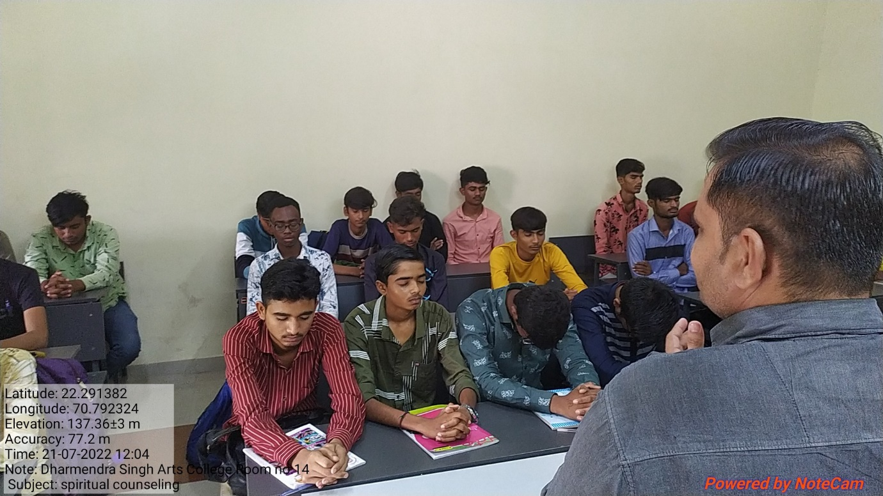
Goal
· Awareness of the spiritual and psychological problems
Context
This year we decided to focus on an inevitable part of overall health i.e. spiritual health.
Practice / mechanism of organization and implementation:
Dr. Bhavesh Kachhadiya and Dr Jignesh Kacha discussed the psychological and spiritual aspects of health with studentson 21/07/22. .
Evidence of success/ beneficiaries:
Students became aware of the lapse in mental and spiritual health and hygiene related issues.
Problems encountered & resources required:
The only problem we face in this program is that students are not exposed to scientific and medical information related to psychological problems.
Best Practice 2: Contribution to Research
International Conference
11/02/2023
https://dhcollege.ac.in/event-details.php?id=526
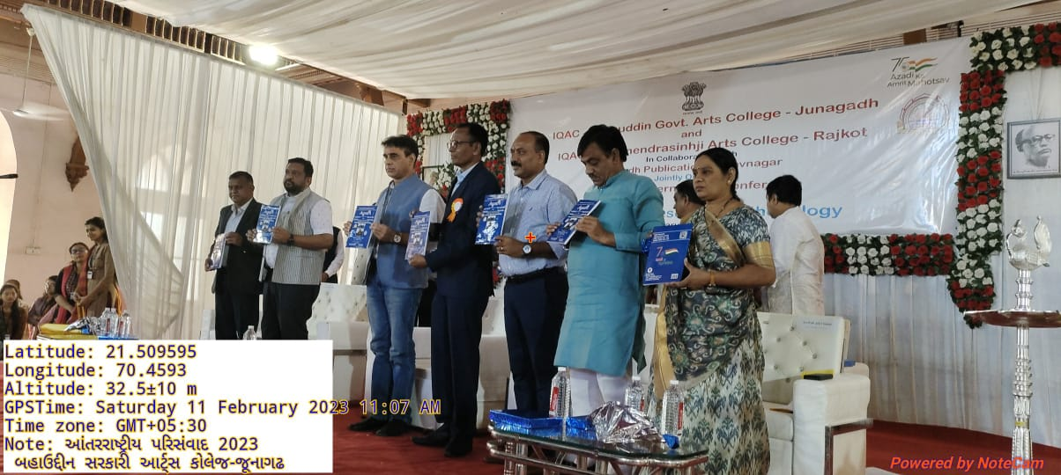
Goal
· To orient students and teachers towards research
Context
The institute organized an international conference on “Research & Research Methodology” on 11/02/2023.
Practice / mechanism of organization and implementation:
There were inaugural, paper reading and valedictory sessions.
Evidence of success/ beneficiaries:
The conference was attended by more than 600 participants.
Problems encountered & resources required:
Due to a large number of participants, the parallel sessions were a little difficult but all arrangements were done by the organizers by overcoming hurdles.

